**Math Homework**

1. **Complete each clock with the correct time.**

**2. Show as many ways as you can to make the number 7.**

**5+2=7**

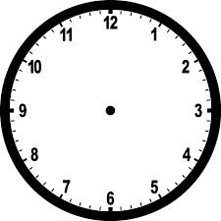

5:00



7:00

**3. Show 5 different ways to represent 25 cents**

**Example: *(Dime) (Dime) (Nickel)***

**1.**

**2.**

**3.**

**4.**

**5.**



1:00

**4.Circle the number that is not correct in each strip.**

55

56

65

58

59

92

93

94

95

97

100

111

102

103

104

79

78

80

81

82

**6. Mr. Smith has 22 notebooks. There are 25 students in Mr. Smith’s class.**

**Are there enough notebooks for the class?**

**Yes No**

**Does Mr. Smith need more notebooks?**

**Yes No**

**How many?____________________**

**5. Ms. Lee has 22 notebooks. There are 19 students in Ms. Lee’s class.**

**Are there enough notebooks for the class?**

**Yes No**

**Are there any extra notebooks?**

**Yes No**

**How many?____________________**

____________________

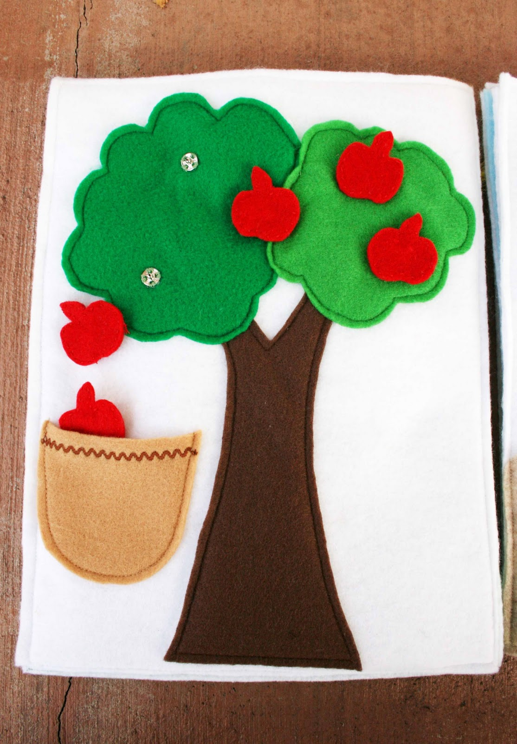

**11. Answer all of the equations.**

**5+1=**

**6+1=**

**5+2=**

**6+2=**

**8+2=**

**1+2=**

**2+5=**

**3+5=**

**12. Write an equation to represent this picture.**

**10. Using dots fill in the ten frames correctly.**

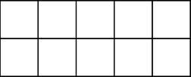









2

4

**10**

8

**9. What number does this ten frame represent?**

**EXPLAIN** how you knew the number.

_______________________________________________

_______________________________________________

**8 . Ms. McKenny has 12 pencils. There are 24 students in Ms. McKenny’s class.**

**Are there enough pencils for the class?**

**Yes No**

**Are there any extra pencils?**

**Yes No**

**How many?____________________**

**7 . Ms. Gray has 28 prizes. There are 19 students in Ms. Gray’s class.**

**Are there enough prizes for the class?**

**Yes No**

**Are there any extra prizes?**

**Yes No**

**How many?____________________**

5

