**Math Homework**

**2. Show as many ways as you can to make the number 10.**

**5+5=10**

1. **What will it be in 1 hour?**



[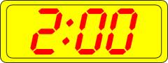](http://www.google.com/imgres?imgurl=http://www.clker.com/cliparts/8/a/e/2/12236133801367466775manio1_Digital_Clock_2.svg.med.png&imgrefurl=http://www.clker.com/clipart-digital-clock-8.html&h=113&w=300&sz=6&tbnid=9e0InEA6-vxGtM:&tbnh=49&tbnw=130&zoom=1&usg=__lbdUBzVPv5HBObMpwKIyn6Td1_0=&docid=1mTsKtBPTAWnBM&sa=X&ei=S9Y1Uu_OBavi4APBtoH4Dg&ved=0CDEQ9QEwAg&dur=541)

[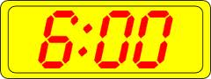](http://www.google.com/imgres?imgurl=http://www.clker.com/cliparts/4/6/0/d/12236134351831335773manio1_Digital_Clock_10.svg.med.png&imgrefurl=http://www.clker.com/clipart-digital-clock.html&h=113&w=300&sz=7&tbnid=C6jJjMFH15bV9M:&tbnh=46&tbnw=122&zoom=1&usg=__r_0nGpYS_tLTU3euTV78KKeeuOM=&docid=3K7pVM38IGXZYM&sa=X&ei=Etc1Up_6Bo-p4AOslICwCA&ved=0CC4Q9QEwAQ&dur=299)

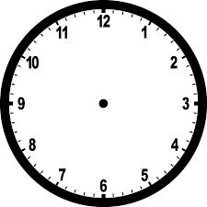







**3. Circle the correct ways to show 25 cents.**

**1. 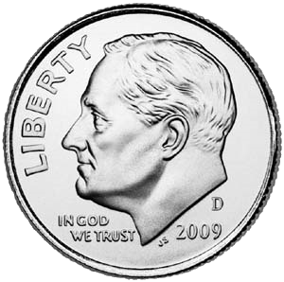 [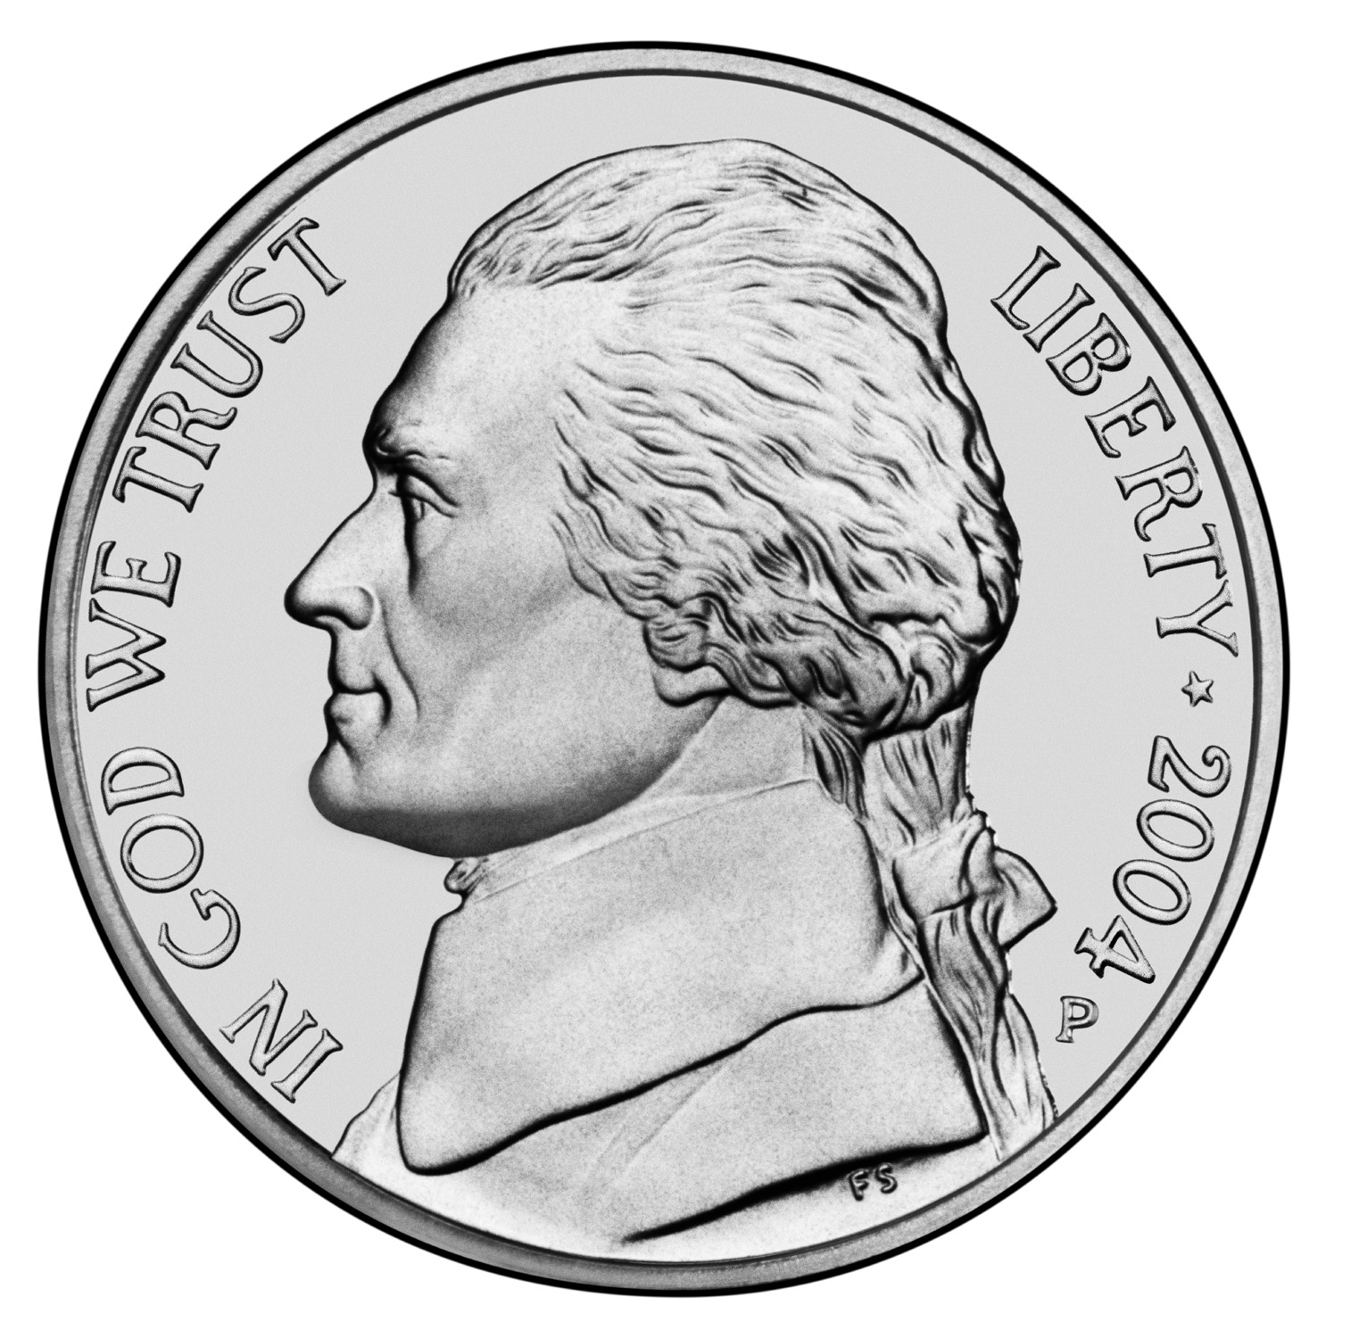](http://www1.bellevuepublicschools.org/curriculum/k6web/firstgrade/money/mixespennynickel1.htm)**

**2. [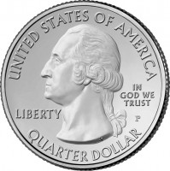](http://www.parkquarters.com/wp-content/uploads/2009/11/Park-Quarter-Obverse-Design.jpg)**

**3.** **[](http://www1.bellevuepublicschools.org/curriculum/k6web/firstgrade/money/mixespennynickel1.htm)**[](http://www1.bellevuepublicschools.org/curriculum/k6web/firstgrade/money/mixespennynickel1.htm)

**4. [](http://www1.bellevuepublicschools.org/curriculum/k6web/firstgrade/money/mixespennynickel1.htm)**

**4. Make the sum of each set of cards equal to 10.**

**EX: 1.**

**2. 3.**

**4. 5.**

**6. 7.**

5

6

4

2

3

8

6

0

9

**5. Using dots fill in the ten frames correctly.**

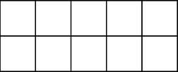









**6 . Ms. Black has 18 pencils. There are 24 students in Ms. Black’s class.**

**Are there enough pencils for the class?**

**Yes No**

**Does Ms. Black need more pencils?**

**Yes No**

**How many?____________________**

**Show your work?**

* **10 = 5 + ___**
* **10 = 4 + ___**
* **10 = 3 + ___**
* **10 = 2 + ___**
* **6 + ___= 10**
* **___+ 6= 10**
* **___+5 = 10**
* **1+ ___= 10**
* **5 + ___= 10**
* **2+ ___= 10**
* **4+ ___= 10**
* **8+ ___= 10**

**7. Fill in each blank to make each number sentence true.**

**6. Mr. Green has 26 media books. There are 22 students in his next class.**

**Are there enough books for the class?**

**Yes No**

**Will there be any extra books?**

**Yes No**

**How many?____________________**

**Show your work?**

15



12

19